**2023-2024 ACADEMIC 30 AĞUSTOS SECONDARY SCHOOL**

**2ND TERM 1ST ENGLISH WRITTEN EXAM FOR 7TH GRADES**

**NAME and SURNAME:**

**CLASS- 7 / ………… NUMBER:…………….**

1. **Read the text and answer the questions. (Soruları metne göre cevaplayınız) (4x4=16pts)**

**.**

1.What does Emre prefer watching?

………………………………………………..…………

2.Does Ece watch talk shows?

…………………………………………….……..……..

3.What does Ece think about soap operas ?

………………………………………………….….……

4.What is her favourite Tv programme?

…………………………………………………….…….

**Hi! I'm Ece. I like watching television. I prefer talk shows to documentaries because they are funny. I never watch soap operas. I find them boring. However, my favorite programme is the quiz shows. To be honest, I never miss them. It's amusing to test myself. You can also win the big prize. My brother Emre never watches quiz shows. He prefers soap operas to other tv programmes**

1. **Answer the questions.(Soruları cevaplayınız)** **(4x4=16pts)**

1-When were you born?.....................................................................................................................

2- What will you be in the future?........................................................................................................

3-Which one do you prefer watching quiz shows or reality shows? Why?..................................................................................................................................................

4-What kind of parties do you like?.......................................................................................................

**C-Read the message and complete the table.(Soruları metne göre cevaplayınız) (6x3=18p)**

**PARTY NOTES!**

**Type of the party:……………………….…….……**

**Date of the party:……………………………………**

**Place of the party:………………………………….**

**Time of the party: ………………………………..**

**Invitee: …………………………………………………**

**Inviter: …………………………………..…………….**

Hi Teressa,

I’m going to have a slumber party at my home. It’s on Friday and starts at 9 pm. We’ll have a great time. Would you like to join?

Love,

Brenda



**D-Answer the question. (Soruyu cevaplayınız.) (4x4= 16pts)**



**What do I need to organize a party?**

Ex: To do list

1-………………………………………………

2-……………………………………………..

3-………………………………………………

4-………………………………………………

**E-What are Aylin’s dreams about future? Write 4 sentences by using “will”.(Aylin’in gelecek ile ilgili hayallerini yazınız) (4x4=16pts)**

1-…………………………………………………………………………………….

2-……………………………………………………………………………………

3-……………………………………………………………………………………

4-…………………………………………………………………………………..



University

A big house

A car

**F. Read Emma’s speech bubble below and answer the questions.(Soruları paragrafa göre cevaplayınız) (4x4=16pts)**

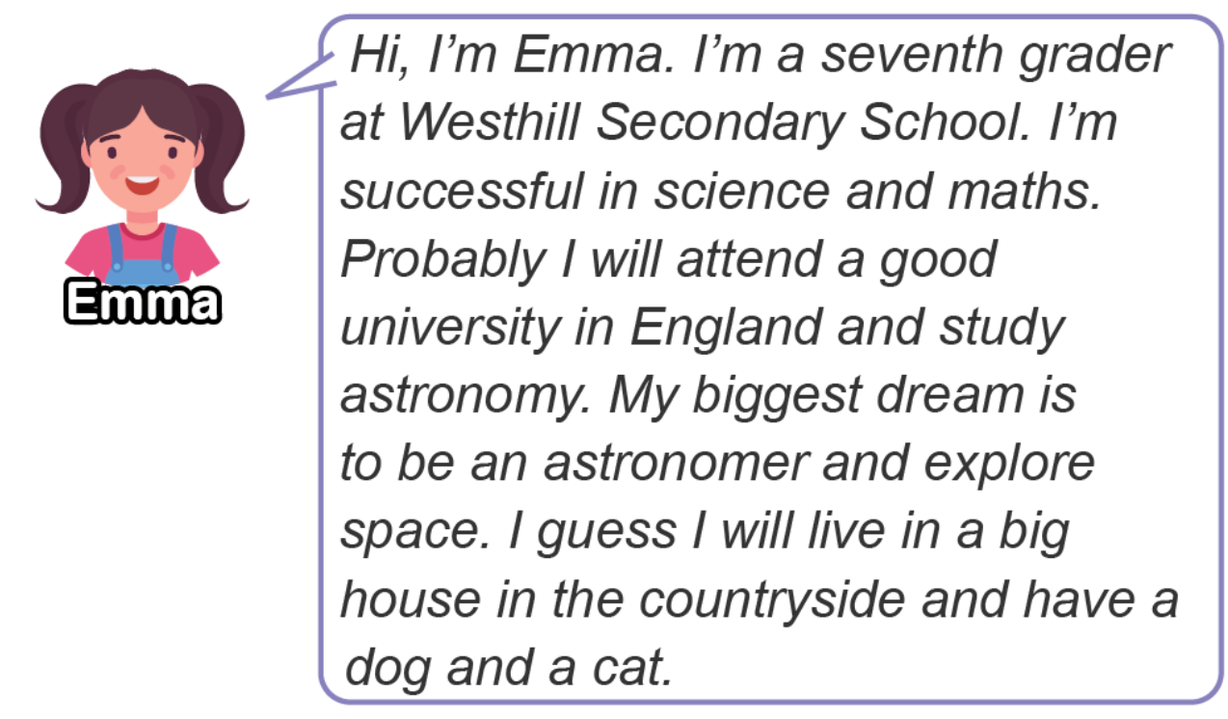

1.What will Emma study at the university?

……………………………………………………………………………………………………………………………

2. Which subject is she succesful in?

……………………………………………………………………………………………………………………………

3. What is her biggest dream?

……………………………………………………………………………………………………………………………

4. Will she live in a big city?

……………………………………………………………………………………………………………………………

**G-Answer the question(Soruyu cevaplayınız) (2pts)**

1.What is your dream for future?.........................................................................................................

GOOD LUCK 😊😊

Fatma YILDIZ Erkan DENİZ Işıl KAYGUSUZ Eda DÖNMEZ Ahmet Giray DEŞER