**2019-2020 ACADEMIC YEAR 30 AĞUSTOS SECONDARY SCHOOL**

**1ST TERM 1ST ENGLISH EXAM FOR 7TH GRADES**

**Name-Surname:**

**Number: Class: 7/G MARK:**

1. **Kutucuktaki kelimeleri uygun kategoriye yerleştiriniz. (10x2=20 pts)**

**cheerful / well-built / generous / handsome / tall / blonde / smart / plump / easygoing / honest**

**Physical Appearance** **Personality**

1. __________________________
2. __________________________
3. __________________________
4. __________________________
5. __________________________
6. __________________________
7. __________________________
8. __________________________
9. __________________________
10. __________________________

**C) Aşağıdaki tanıtımları okuyup kişilerin adlarını resimlerin altına yazınız. (5x3=15 pts)**

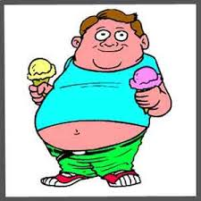  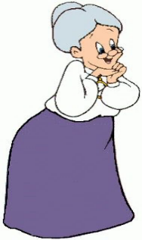    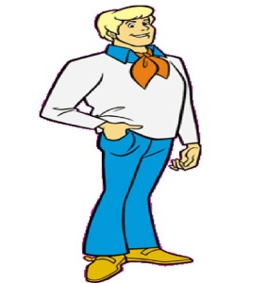

_______________ _________________ _________________ _________________ __________________

1) **Ahmet:** He is a handsome boy. He is tall and slim. He has got short blond hair.

2) **Fatma:** She has got long grey hair. She is old.

3) **Ali:** He has got short, wavy, brown hair. He is overweight.

4) **Özlem:** She has got long wavy hair. She is very beautiful with big eyes.

5) **Dursun:** He has got short curly hair and a big nose.

**D) Her kategoriye uygun iki spor ismi yazınız. (8x2=16 pts)**

|  |  |  |  |
| --- | --- | --- | --- |
| **Individual sports** | **Team sports** | **Outdoor sports** | **Indoor sports** |
| 1-  2- | 1-  2- | 1-  2- | 1-  2- |

**E) Koyu yazılan kısımlardan doğru olanı daire içine alınız. (6X3=18 pts)**

1. She is **taller / more tall**  than my other friends.

2. English is **easyer / easier**  than French.

3. They are **slimmer / slimmer** than us.

4. Lions are  **more dangerous / dangerouser**  than horses.

5. My sister is **more hardworking / most hardworking**  than my brother.

6. Real Madrid is **badder / worse** than Barcelona.

**F) Choose the best answer (10X3=30 pts)**

|  |  |
| --- | --- |
| ***1. A: What does George look like?***  ***B: ………………………………………………………………………. .***  *A) He is tall and well-built.*  *B) He is quiet and shy.*  *C) He is helpful and polite.*  *D) He likes swimming.*  ***2. Ketty : ________________ ?***  ***Silvia : She is easygoing and friendly.***  *A) What is Jane like?*  *B) What does Jane like?*  *C) What does Jane look like?*  *D) What is Jane look like?*  ***3. ______ is an indoor sport. You need a special white suit and a belt.***   1. *Archery B) Karate C) Hiking D) Swimming*   ***4. My sister is taller _____ Liz.***  *A) to B) ___ C) than D) at*  **5. Which one is different(farklı)?**  A) hazel B) curly C) straight D) wavy  **6. Football is _________ tennis in Turkey.**  **A)** popular more than  **B)** the more popular  **C)** popular than  **D)** more popular than | **7. Joe______ long, black hair and green eyes.**   1. have got **B)** is **C)** has got **D)** does   **8. Selin is an easygoing and punctual girl ___ she is forgetful and selfish.**   1. and B) but C) so D) because   **straight hair clipart ile ilgili görsel sonucu9. What does she look like?**  **A)** She has got long straight hair.  **B)** She has got short wavy hair.  **C)** She has got long curly hair.  **D)** She has got short straight hair.  **forgetful clipart ile ilgili görsel sonucu**  **10. My grandmother cannot remember**  **things. She always forgets. She is ______.**  **A)** punctual **B)** forgetful  **C)** well-built  **D)** outgoing    ***11- What is your name ?(1 point)***  *……………………………………………………………………………………….. .*  **GOOD LUCK ☺**  **FATMA YILDIZ** |