**2023-2024 ACADEMIC YEAR 30 AĞUSTOS SECONDARY SCHOOL**

**2nd TERM 1st READING &WRITING ENGLISH EXAM**

**Name-Surname:**

**Class:**

**No:**

1. **Write the suitable words.(Resimlerin altına uygun kelimeleri yazınız.)**

|  |  |  |  |  |
| --- | --- | --- | --- | --- |
| ***Carrousel*** | ***Bumper cars*** | ***Ghost train*** | ***Roller coaster*** | ***Ferris wheel*** |

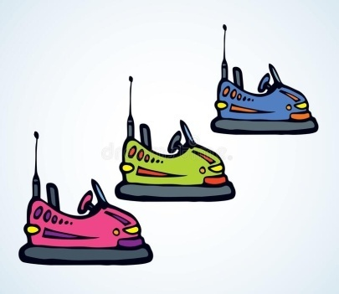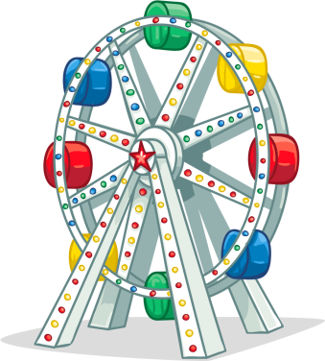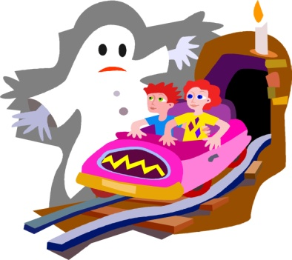

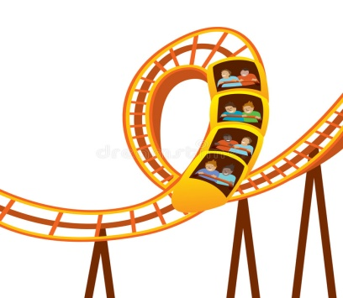



**B- Find the hidden occupations in the puzzle. (Bulmacada gizlenmiş mesleklerden bulup yazınız)**

|  |  |  |  |  |  |  |  |  |  |  |  |  |
| --- | --- | --- | --- | --- | --- | --- | --- | --- | --- | --- | --- | --- |
| **P** | **D** | **D** | **V** | **B** | **M** | **Y** | **I** | **I** | **K** | **V** | **E** | **T** |
| **O** | **T** | **E** | **A** | **C** | **H** | **E** | **R** | **S** | **T** | **B** | **B** | **J** |
| **L** | **W** | **X** | **C** | **X** | **C** | **V** | **Z** | **C** | **B** | **U** | **P** | **A** |
| **I** | **W** | **C** | **T** | **S** | **D** | **E** | **N** | **T** | **I** | **S** | **T** | **A** |
| **C** | **M** | **Y** | **O** | **E** | **S** | **E** | **Z** | **F** | **F** | **T** | **H** | **S** |
| **E** | **D** | **F** | **R** | **G** | **H** | **J** | **K** | **L** | **E** | **Z** | **V** | **T** |
| **M** | **Q** | **W** | **Z** | **E** | **N** | **G** | **I** | **N** | **E** | **E** | **R** | **U** |
| **A** | **Q** | **E** | **T** | **E** | **T** | **Y** | **E** | **U** | **I** | **O** | **P** | **D** |
| **N** | **Z** | **C** | **X** | **B** | **D** | **F** | **N** | **M** | **E** | **T** | **G** | **E** |
| **A** | **A** | **S** | **D** | **C** | **S** | **O** | **E** | **T** | **Y** | **Y** | **U** | **N** |
| **W** | **A** | **I** | **T** | **E** | **R** | **X** | **C** | **V** | **B** | **E** | **W** | **T** |
| **C** | **R** | **Q** | **A** | **K** | **A** | **A** | **S** | **T** | **P** | **O** | **I** | **Y** |
| **B** | **F** | **Y** | **O** | **L** | **F** | **G** | **F** | **H** | **O** | **J** | **J** | **K** |
| **H** | **E** | **O** | **I** | **U** | **F** | **V** | **R** | **V** | **R** | **R** | **T** | **L** |
| **T** | **C** | **I** | **L** | **L** | **N** | **U** | **R** | **S** | **E** | **D** | **B** | **J** |

1-………………………………………………….

2-………………………………………………….

3-…………………………………………………

4-…………………………………………………

5-…………………………………………………

**C- Fill in the blanks with ‘ WAS & WERE ‘ (Boşlukları Was veya Were ile tamamlayınız)**

1. Atatürk …………………… born in 1881.
2. Atatürk …………………….born in Selonika.
3. They ……………………….. at the school.
4. We ………………………….. in the park yesterday.
5. Selma ………………………. İn the hospital.

D- **Match the words with the pictures. (Resimlerin altına mesleklerini yazınız)**

**1. singer 2. nurse 3. Hairdresser 4. cook 5. teacher**



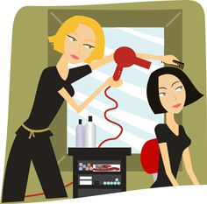

**NOTE: Each question is 5 points.**

**GOOD LUCK 😊**

**Fatma YILDIZ**

**English Teacher**