**2023-2024 ACADEMIC YEAR 30 AĞUSTOS SECONDARY SCHOOL**

**6th GRADES ENGLISH 1st TERM 2nd WRITING EXAM**

**NAME AND SURNAME:**

**NUMBER AND CLASS:**

1. **KUTUCUKTAKİ KELİMELERİ BULMACADAN BULUNUZ.(10X3=30PTS)**

**Old Beautiful Fat Handsome Short Tall Slim Happy Funny New**

|  |  |  |  |  |  |  |  |  |  |
| --- | --- | --- | --- | --- | --- | --- | --- | --- | --- |
| **O** | **R** | **T** | **T** | **G** | **S** | **U** | **I** | **O** | **P** |
| **L** | **S** | **Z** | **Q** | **W** | **H** | **E** | **Y** | **O** | **M** |
| **D** | **V** | **B** | **W** | **A** | **O** | **C** | **Y** | **H** | **F** |
| **L** | **B** | **M** | **T** | **X** | **R** | **E** | **E** | **F** | **S** |
| **T** | **B** | **E** | **A** | **U** | **T** | **I** | **F** | **U** | **L** |
| **F** | **G** | **J** | **L** | **K** | **K** | **U** | **I** | **N** | **I** |
| **D** | **P** | **N** | **E** | **W** | **T** | **E** | **M** | **N** | **M** |
| **H** | **A** | **N** | **D** | **S** | **O** | **M** | **E** | **Y** | **U** |
| **D** | **W** | **E** | **T** | **Y** | **P** | **L** | **B** | **N** | **M** |
| **H** | **A** | **P** | **P** | **Y** | **T** | **A** | **G** | **F** | **B** |
| **E** | **R** | **G** | **Y** | **P** | **F** | **A** | **T** | **P** | **N** |

1. **KUTUCUKTAKİ YİYECEK ADLARINI UYGUN KATEGORİYE YAZINIZ.(10X3=30PTS)**

**Coffee hamburger tomatoes apple sausages**

**Milk pizza fish carrot fries**

|  |  |
| --- | --- |
| **HEALTHY (SAĞLIKLI )** | **UNHEALHTY (SAĞLIKSIZ)** |
|  |  |
|  |  |
|  |  |
|  |  |
|  |  |

**C-HAVA OLAYLARINI UYGUN RESIMLERİN ALTINA YAZINIZ.(10X3=30PTS)**

Sunny cloudy rainy snowy windy

Freezing foggy lightning hailing partly cloudy











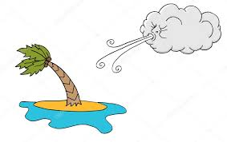

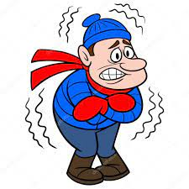







1. **AŞAĞIDAKİ SORULARI CEVAPLAYINIZ?(2x5=10pts)**
2. **Who is taller in your family? Your mom or your dad?**

**…………………………………………………………………………………….**

**2-What time do you get up?**

**…………………………………………………………………………………….**

**GOOD LUCK 😊**

**Fatma YILDIZ**