|  |  |  |  |  |  |  |
| --- | --- | --- | --- | --- | --- | --- |
|  |  | **………………………………..**  **SECONDARY SCHOOL**  **2023-2024 ACADEMIC YEAR**  **6TH GRADERS’ 1ST TERM 2ND WRITTEN EXAM** | | |  |  |
| Name-Surname: | | Class 6/  Number: | POINT: | |

**A-Look at the pictures and write what they are doing now. ( Resimlerdeki kişilerin şuan ne yaptığını yazınız)**

metin, kolaj, ekran görüntüsü, köpek içeren bir resim

Açıklama otomatik olarak oluşturuldu

**1.** Peter ……………………………………………………………………………………………………

**2.** Mary ……………………………………………………………………………………………………

**3.** Kate …………………………………………………………………………………………………….

**4.** Derek…………………………………………………………………………………………………..

**B- Read the text, correct the mistakes, and rewrite the sentences.( Paragrafa göre aşağıdaki cümlelerdeki yanlışları bulup düzelterek yeniden yazınız)**

Michael wakes up at 7 am on weekdays. He has breakfast with his family at 7:30 am. He leaves home at 8 am

and walks to school with his best friends, Alex and Sandy. His lessons start at 8:30 am. After he returns

home, he takes a nap. He does his homework at 4 pm, then he plays with his friends outside. After dinner,

he reads a book with his parents. He goes to bed at 9 pm.

**1.** He has breakfast at school.

---------------------------------------------------------------------------------

**2.** His dad drives him to school every day.

---------------------------------------------------------------------------------

**3.** After Michael comes back home, he watches TV.

---------------------------------------------------------------------------------

**4.** Michael plays games on the Internet after doing his homework.

---------------------------------------------------------------------------------

**C- According to the talks and food preferences, write the correct names under the pictures.(Yedikleri yiyeceklere göre çocukların adlarını resimlerin altına yazınız)**

**Kate :** I eat cereal with milk. I eat cheese and honey. I drink milk.

**Larry :** I eat omelette and cheese. I drink tea.

**Simon :** I eat croissants, jam and grapes. I drink milk.

**Jullia :** I eat a sandwich and beans. I drink orange juice and tea.

meyve, yemek, gıda, kırpıntı çizim, çizgi film içeren bir resim

Açıklama otomatik olarak oluşturuldu

**D- Look at the table and answer the questions.(Tablodaki bilgilere göre soruları cevaplayınız)**

|  |  |
| --- | --- |
|  | Mutlaka Görülmesi Gereken Şehir - İzmir | Duray Rent A Car |
| **Population: 2.175.601** | **Population: 4.462.056** |
| **Weather (C): Winter : 2 C**  **Summer 25 C** | **Weather (C) : Winter :7 C**  **Summer: 34 C** |
| **Area : 105 km** | **Area: 11.891 km** |

|  |  |
| --- | --- |
| **Paris, FRANCE** | **İzmir, TURKIYE** |

**1-Which city is hotter?**

**2-Is Paris colder than İzmir?**

**_________________________________________**

**3-Which city is more crowded?**

**4-Which city is larger?**

**_____________________________________________**

**E-Answer the questions about yourself.(Soruları cevaplayınız)**

1-What is the weather like in summer in İzmir?

………………………………………………………………………………………………………………………………………...

2- What time do you go to bed?

………………………………………………………………………………………………………………………………………….

3- Who is taller than you in your family?

…………………………………………………………………………………………………………………………………………….

**F- Complete the text according to the weather map (Haritaya göre hava durumlarını yazarak metni tamamlayınız)**

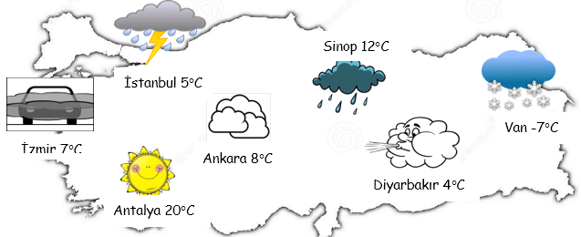

|  |
| --- |
| **News Reporter:** Hello everyone. Let’s see how the weather is today in Turkiye. İstanbul is …………………………………………….. İzmir is …………………………………………….. Antalya………………………………………… and hot. Ankara is cloudy and warm. Diyarbakır is ………………………………………….. and 4 degrees Celsius. Take your umbrella because Sinop is ……………………………………. Lastly, Van is …………………………………………. and freezing.  Have a good day :) |

**GOOD LUCK 😊😊**

**Note: Each question is 4 points**