2018-2019 ACADEMIC YEAR AHMET PAŞA SECONDARY SCHOOL 6/D CLASS SECOND TERM SECOND WRITTEN ENGLISH EXAM

Name Surname:
Number: MARK:

I) Match the activities with the pictures. (4x5=20 points) (Resimlerle etkinlikleri eşleştiriniz)
rafting – hiking – diving – skiing – sailing
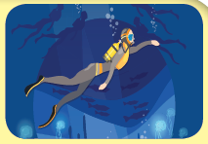 |  |  |  | 
1. | 2. | 3. | 4. | 5.

II) Circle the correct one. (2x5=10 points) (Doğru olan seçeneği daire içine alınız)
1) We walk / walked in the forest last Saturday.
2) The weather is rainy today / yesterday.
3) My friend and I was / were in Erzurum two days ago.
4) My sister didn’t help / helped my mom yesterday
5) My mom cooks / cooked spaghetti every Saturday.

III) Read the conversation and answer the questions. (2x5=10 points) (Diyaloğu okuyup soruları cevaplayınız)
Meghan: Hello, this is Meghan speaking.
Tracy: Hi, Meg. I called you at 4 p.m. yesterday, but you didn’t answer. Where were you?
Meghan: I was in the library all day yesterday. I looked for some important books about my science project and came back home at about 5. Why did you call me?
Tracy: I had an ice-skating course yesterday. I lost my skates and wanted to borrow yours.
Meghan: Oh, really? I’m so sorry about it.
Tracy: Don’t worry! I called Sue later and she lent me her skates.
Meghan: I’m happy to hear that. How was your course?
Tracy: It was difficult for me. I fell many times and hurt my leg.
Meghan: Oh! Get well soon. How do you feel now?
Tracy: Thank you. I feel better now. See you later!
Meghan: See you!
1) Did Meghan answer the phone yesterday?
________________________________________________________________________________________
2) Where was Meghan yesterday?
________________________________________________________________________________________
3) What time did Meghan come back home?
________________________________________________________________________________________
4) Whose ice-skates did Tracy borrow?
________________________________________________________________________________________
5) How does Tracy feel now?
________________________________________________________________________________________
IV) Fill in the blanks with the given prepositions. (2.5x4=10 points) (Boşlukları verilen edatlarla doldurunuz)
next to – in – between – under
 | 1) The fish is _______________ the aquarium. |  | 2) Ahmet is __________________ Nazlı and Canan.
 | 3) The mechanic is _____________ the car. |  | 4) There is a house _____________ the museum.

V) Circle the correct option (2.5x10=25 points) (Doğru seçeneği yuvarlak içine alınız)
1. What is Jane doing?  a) She is running errands.  b) She is taking a nap.  c) She is climbing a mountain.  d) She is doing her homework.  2. Gill: What is your favourite food?  Jerry: It is _______.  a) sausage  b) pancake  c) bagel  d) croissant  3. The plane is ___________ the car.  a) faster than  b) fast than  c) short than  d) shorter than  4. Tom: How do you feel in ___________weather?  Buse: I feel _________.  a) cloudy/upset b) rainy/sleepy  c) sunny/happy d) foggy/moody  5. John: What is your favourite ride at the fair?  Mark: ________.  a) Bumper car  b) Ferris wheel  c) Roller coaster  d) Ghost train | 6. I can cook delicious meals. I’m a _____.  a) doctor b) dentist  c) salesman d) cook  7. Gill: What did you do on your holiday?  Jerry: __________.  a) I learnt diving  b) I stayed in a tent  c) I picked fruits  d) I climbed a mountain  8. There is a painting _____ the wall, _____ the TV.  a) next to/near b) in/on  c) on/over d) near/next to  9. John: What should we do to save our environment?  Mark: ________.  a) We should unplug the TV  b) We should use less water  c) We shouldn’t harm animals  d) We shouldn’t cut down tress  10. Do you have _____ at your school?  a) campaign  b) president  c) candidate  d) election
  
  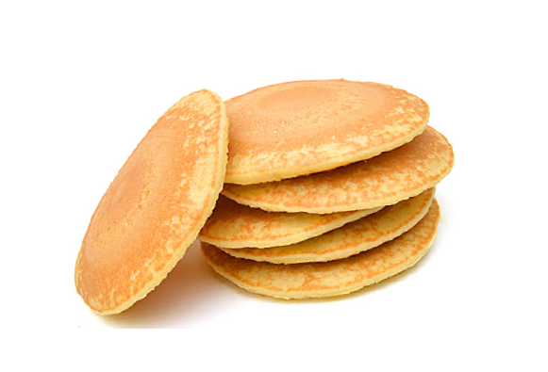
  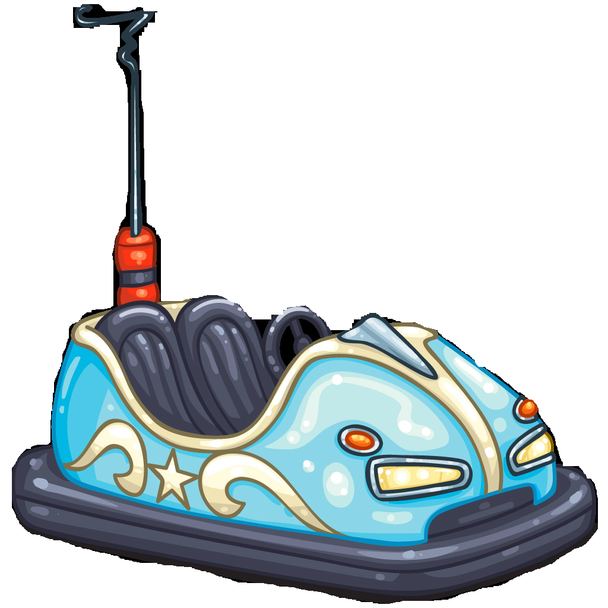
  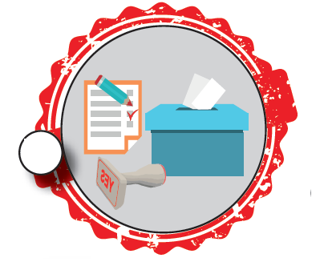

VI) Listen to the song and complete. (5x5=25 points) (Şarkıyı dinleyiniz ve tamamlayınız)
Save the world!
Don’t (1)___________________ litter!
Save the world!
Don’t harm (2)___________________!
Save the world!
Don’t (3)__________________ water!
Save the world!
Don’t cut down (4)_______________!
Save the world!
Save the world!
Save the (5)_____________________!

G☺☺D LUCK!
Ömer Faruk DEMİRTAŞ
English Language Teacher

